



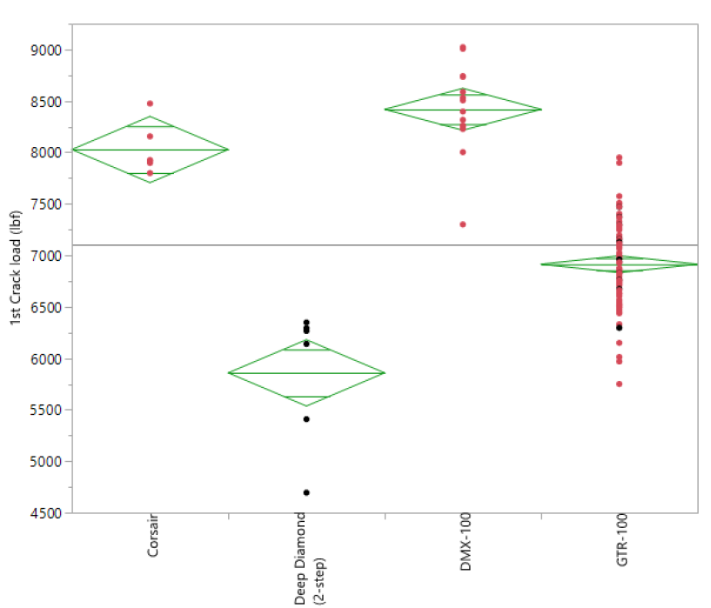
Overload
Cutter
Cutter A
Cutter A
Cutter A

